Image Gallery Software

Use-Case-Realization Specification: Send Message

Version <1.0>

Revision History

|  |  |  |  |
| --- | --- | --- | --- |
| **Date** | **Version** | **Description** | **Author** |
| 17/12/2020 | <1.0> | <details> | Do Minh Hieu |
|  |  |  |  |
|  |  |  |  |
|  |  |  |  |

Table of Contents

1. Introduction 2

1.1 Purpose 2

1.2 Scope 2

1.3 Definitions, Acronyms, and Abbreviations 2

1.4 References 2

1.5 Overview 2

2. Use-Case Specification 4

3. Interaction Diagrams 5

4. Class Diagrams 2

3. Derived Requirements 2

Use-Case-Realization Specification: Send Message

# Introduction

## Purpose

This document describes how the Send Message Use-Case is realized within the design model, in terms of collaborating objects.

## Scope

This document applies to the Image Gallery Software which will be developed by Group 5C-18.

## Definitions, Acronyms, and Abbreviations

User – a person who use the software.

## References

None.

## Overview

In the following section, Use-Case Realization Specification of the Send Message Use-Case of the Image Gallery Software is provided in detail. The first section is a textual description of the Use-Case specification. The following section contains diagrams (sequence and collaboration diagrams) describing how the use case is realized in terms of collaborating objects. The third section includes class diagrams with relationships that participate in the realization of the use case. The last section is an analysis of all requirements, such as non-functional requirements, on the use-case realization that are not considered in the design model, but that need to be taken care of during implementation.

# Use-Case Specification

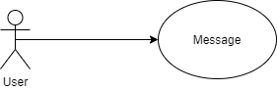

|  |  |
| --- | --- |
| **Name** | Edit Image |
| **Brief Description** | An user edits the picture’s information |
| **Actor** | User |
| **Flow of Events** | |
| **Basic Flow** | |
| 1. Open “Message” tab. 2. User write username of the user they want send message at “Receiver” field and content at the field under it. 3. Click “Send” button. 4. The message will be store on database. 5. The message will be retrieved 6. Display on screen of the other user at the ”Message” tab. | |
| **Alternate Flows** | |
| **Title** | **Description** |
| Authentication fail | The receiver is not existed. |
| **Pre-Conditions** | |
| Receiver is exist. | |
| **Post-Conditions** | |
| **Title** | **Description** |
| Success | Message is display on screen at both user sender and user receiver. |
| Failure | The error message appears and asks user input receiver’s name input. |
| **Extension Points** | |
| None | |

# Interaction Diagrams

**Sequence Diagram:**

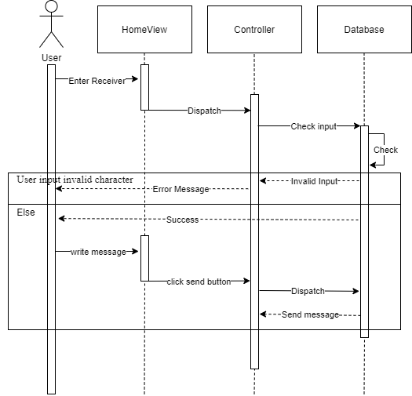

**Collaboration Diagram:** 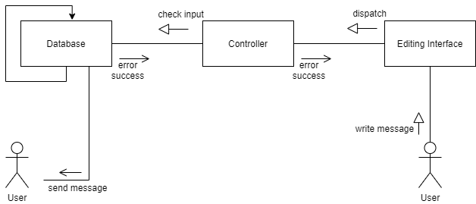

# Class Diagrams

# 

# Derived Requirements

None.